RFID Reader

Assignment 2

Test Documentation

Contributors:

Ruoqi Jia

Jaegar Sarauer

|  |  |  |  |  |  |
| --- | --- | --- | --- | --- | --- |
| Test # | Description | Test | Expected Results | Pass/Fail | Supporting Details |
| 1 | Attempting to connect to reader | Ensure the program isn’t connected. Ensure the RFID read is connected. Click the connect button at the top of the program. Once connected, attempt to read a tag. | The program will attempt to connect with the RFID reader, and prompt the user with success when connected. | PASS | See figure 1. |
| 2 | Read a Tag | Placing a tag on the connected RFID reader while the program is in “connected” mode. | Data about the tag read should be populated to the list view on the program. Including the index of the tag, the name of the tag, and the type. | PASS | See figure 2. |
| 3 | Read different type of tags | Placing different tags on the reader, one at a time, on the RFID reader while the program is in “connected” mode. | Data about each tag should show up in the list view as specified above. The list should include different tag names and tag types. | PASS | See figure 3. |
| 4 | Attempting to disconnect from reader | Ensure the program is connected. Click the disconnect button at the top of the program. Attempt to read a tag after disconnect, expected not to read. | The program will attempt to disconnect from the RFID reader. The user will be alerted on success. | PASS | See figure 4. |
| 5 | Attempting to clear the list view. | Clicking the clear button at the top of the program. | The list view should clear all items populated from within itself. | PASS | See figure 5. |
| 6 | Opening the help window. | Clicking the help butting at the top of the program. | A dialog window containing help information should appear for the user. | PASS | See figure 6. |
| 7 | Window updates when resizing, minimizing, maximizing, and moving the window | Resizing the window while the program is attempting to read a tag in connected mode. Also maximize, minimize and move the window. | The list should stay populated and the program should continue to read. | PASS | See figure 7. |
| 8 | No memory leaks when successive disconnecting/connecting. | Attempt to disconnect and reconnect several times. Monitor memory usage of the program in windows task manager. | The memory should not increase on disconnects and reconnects. | PASS | See figure 8. |
| 9 | How efficient is the list view for keeping track of items. | Attempt to populate the list with 100,000 items. | The list should be as responsive as before, and hold all 100,000 items. | PASS | See figure 8-10. |
| 10 | Attempt to cycle through connect and disconnect, ensuring the features work completely. | Ensure the program is disconnected. Ensure the RFID reader is connected. Connect by clicking the button at the top of the program. Attempt to read a tag. Attempt to disconnect by clicking disconnect at the top of the program. Attempt to read a tag (expected to be not readable). Attempt to connect again. | The program should be able to read a tag and display its information to the list view when connected, and not display any tag when disconnected. The program should be able to reconnect after the first disconnect. | PASS | See all figures. All figures were taken in the same program instance. |

Figure 1 – Connected Prompt

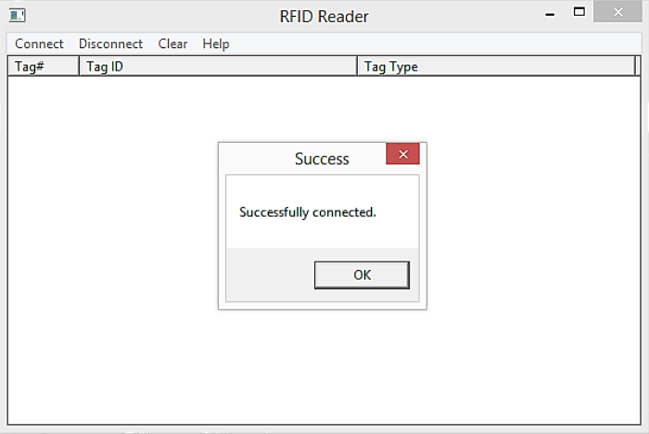

Figure 2 – A Single Tag

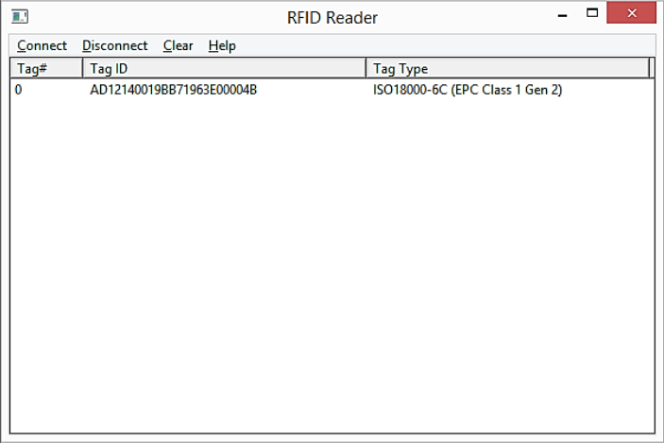

Figure 3 – Several IDs Populated

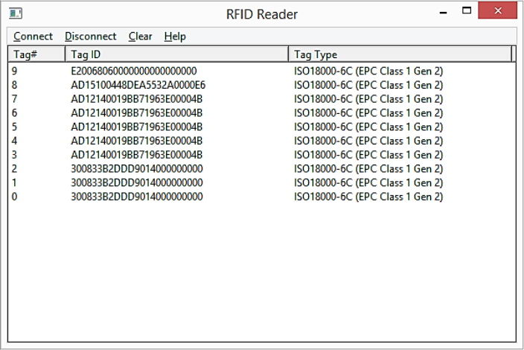

Figure 4 – Disconnected Prompt

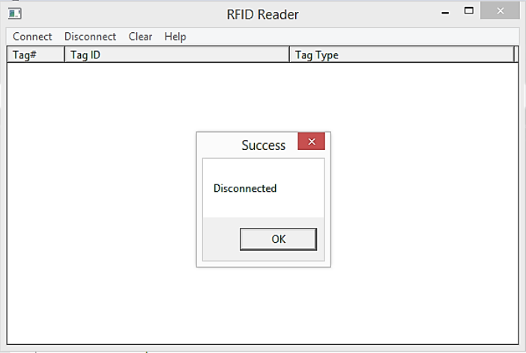

Figure 5 – Cleared List

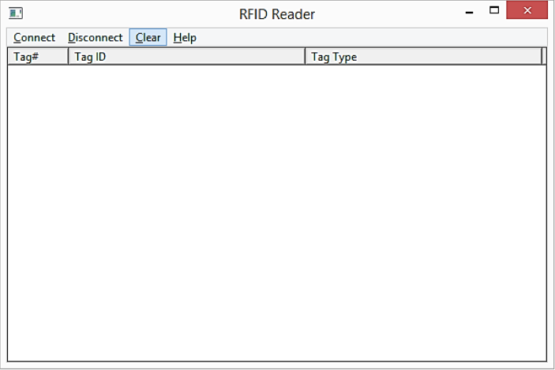

Figure 6 – Help Prompt

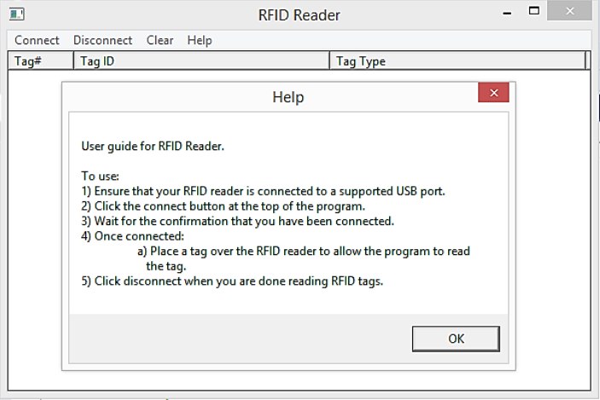

Figure 7 – Resized Window Still Drawn

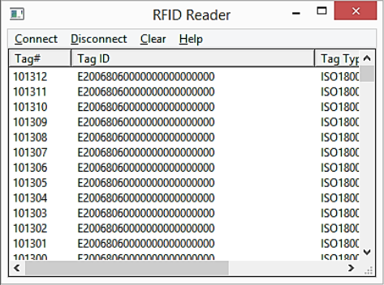

Figure 8 – CPU Usage for Large List

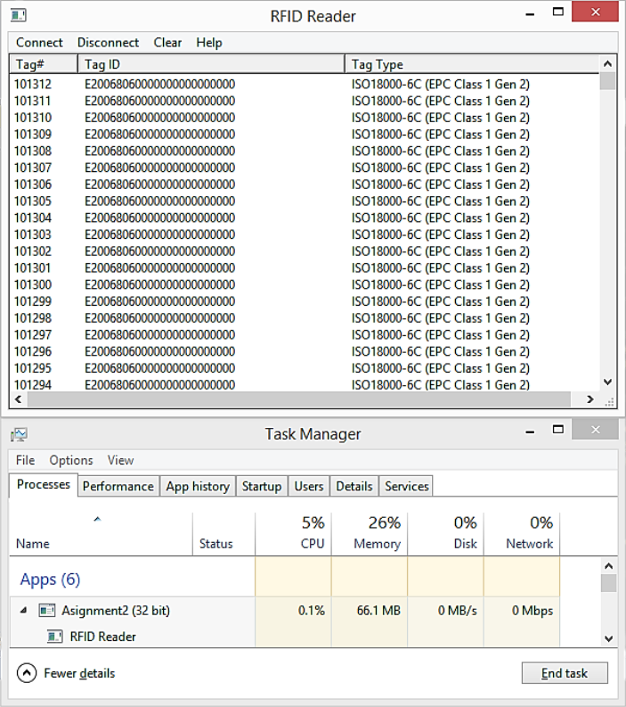

Figure 9 – Large List at the Bottom

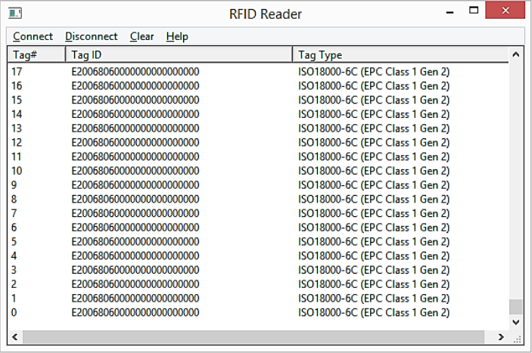

Figure 10 – Large List at the Top

